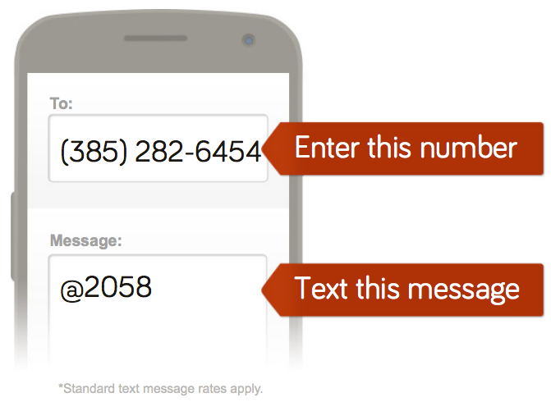

Or to receive messages via email, send an email to [**CODE@mail.remind101.com**](mailto:2058@mail.remind101.com) .

To unsubscribe, reply with ‘unsubscribe’ in the subject line.

You can opt-out of messages at anytime by replying, ‘unsubscribe @Code’.

**Type Your Class HERE**

**[Your Name Here]’s class**

(###) ###-####

Insert “@CODE”



Or to receive messages via email, send an email to [**CODE@mail.remind101.com**](mailto:2058@mail.remind101.com) .

To unsubscribe, reply with ‘unsubscribe’ in the subject line.

You can opt-out of messages at anytime by replying, ‘unsubscribe @Code’.

**Type Your Class HERE**

**[Your Name Here]’s class**

(###) ###-####

Insert “@CODE”



Or to receive messages via email, send an email to [**CODE@mail.remind101.com**](mailto:2058@mail.remind101.com) .

To unsubscribe, reply with ‘unsubscribe’ in the subject line.

You can opt-out of messages at anytime by replying, ‘unsubscribe @Code’.

**Type Your Class HERE**

**[Your Name Here]’s class**

(###) ###-####

Insert “@CODE”



Or to receive messages via email, send an email to [**CODE@mail.remind101.com**](mailto:2058@mail.remind101.com) .

To unsubscribe, reply with ‘unsubscribe’ in the subject line.

You can opt-out of messages at anytime by replying, ‘unsubscribe @Code’.

**Type Your Class HERE**

**[Your Name Here]’s class**

(###) ###-####

Insert “@CODE”











